1. Give a solid blue bottom border to the given content with a thickness 3px using CSS

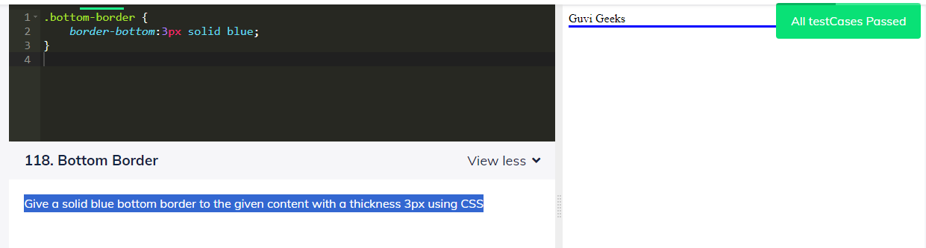

2. Give a solid red top border to the given content with a thickness 3px using CSS

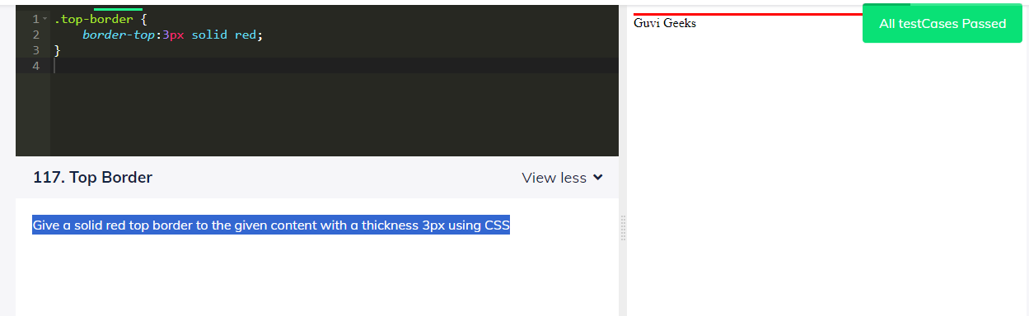

3. Give a solid red right border to the given content with a thickness 3px using CSS

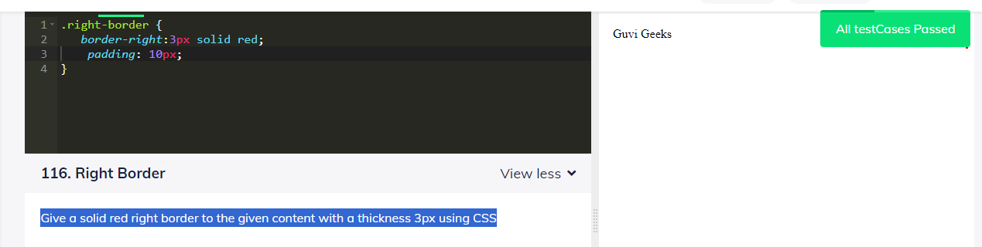

4. Give a solid red left border to the given content with a thickness 3px using CSS

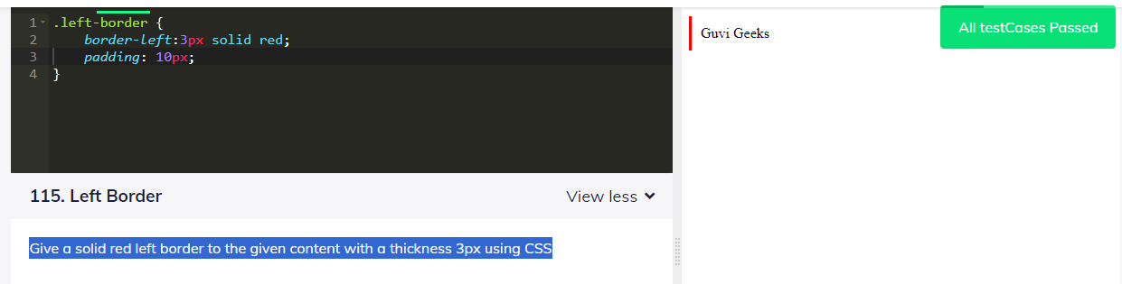

5. Change the background colour of the given rectangle to blue color using CSS

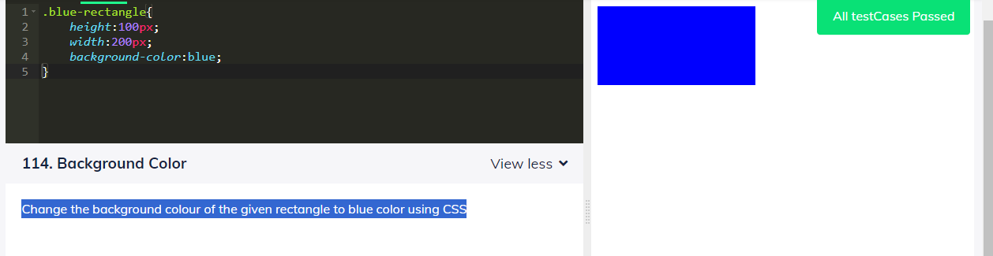

6. Give a solid red border to the given square with a thickness 3px using CSS

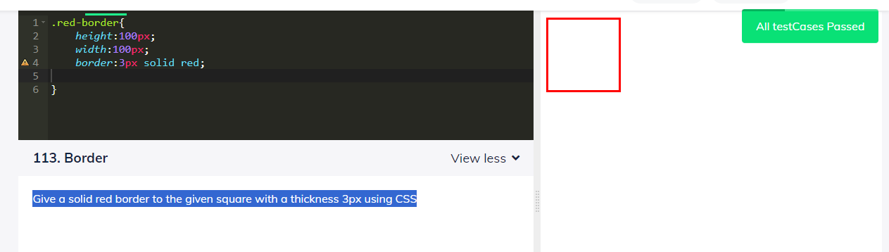

7. Align the contents to center with id_name as "alignToRight" using external CSS

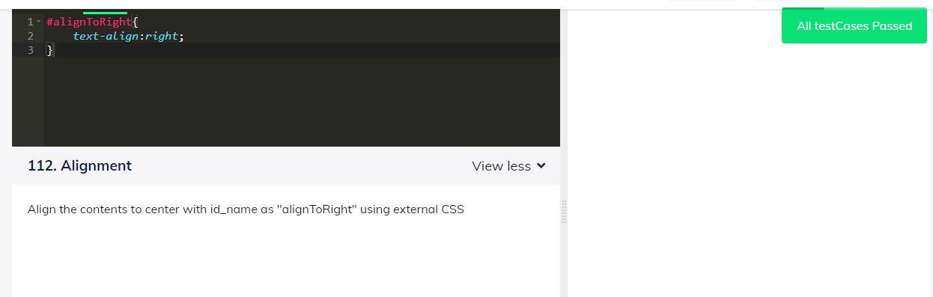

8. Align the contents to center with id_name as "alignToCenter" using external CSS

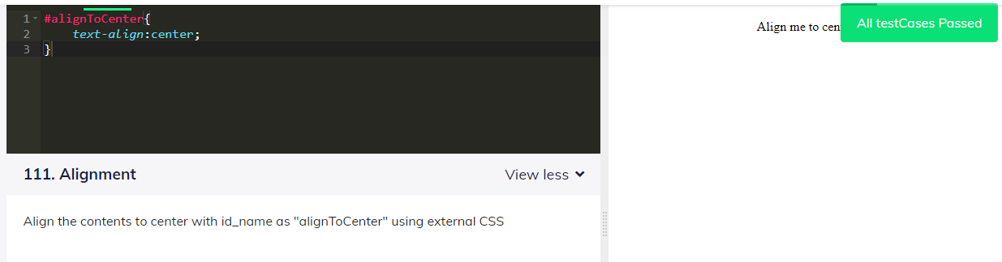

9. Change the colour of the contents of h3 tag to Green color using external CSS

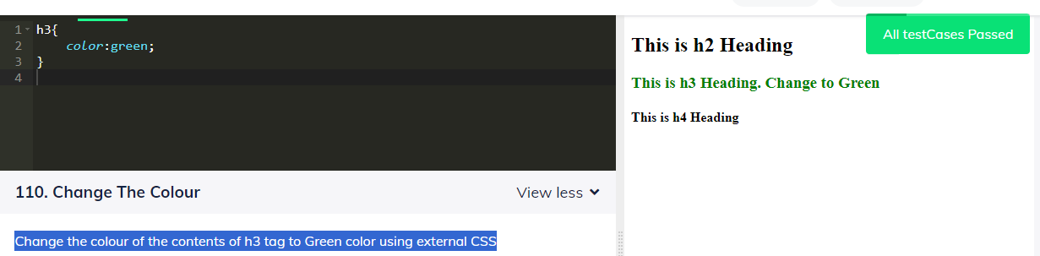

10. Increase the font size of all the elements with class name as "increase" to 30px using CSS

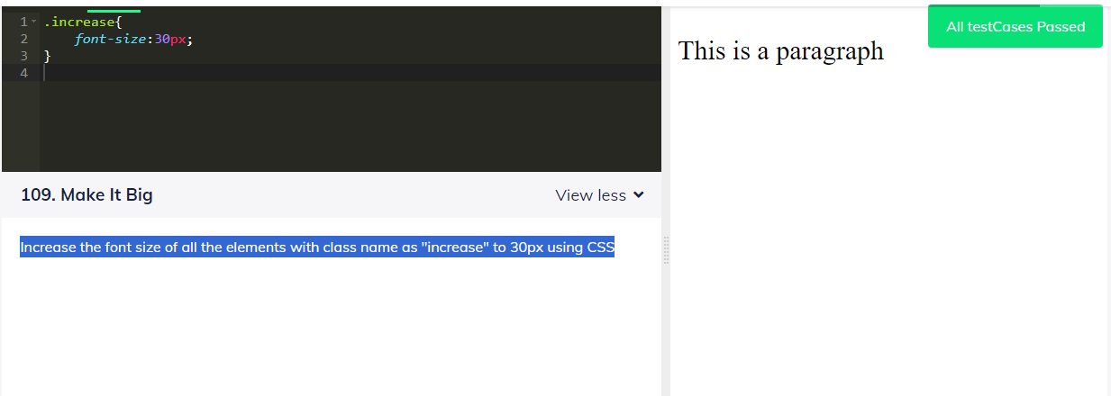

11. Display all the elements with class name as "changeMeToGreen" in a green colour using CSS

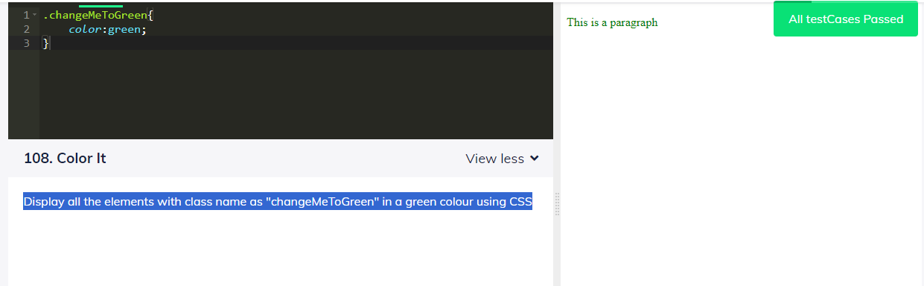

12. Change the flex-direction property to column-reverse

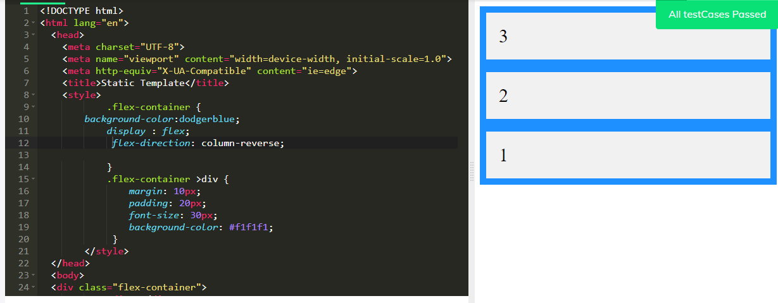

13. Color the given button only at borders with red

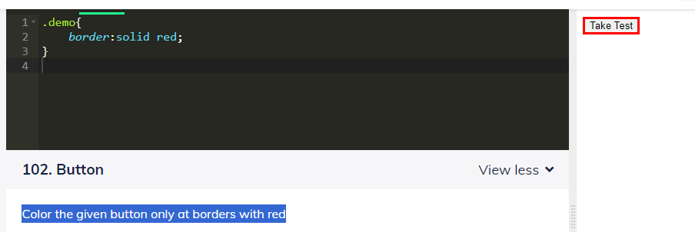

14. Give Green color to the given button using css

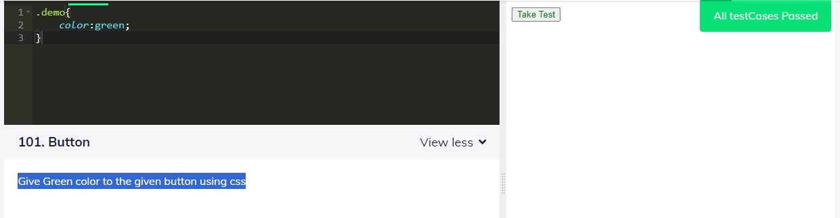

15. Display "Hello from guvian" using padding on all four sides, 10px, with light blue background in a paragraph tag.

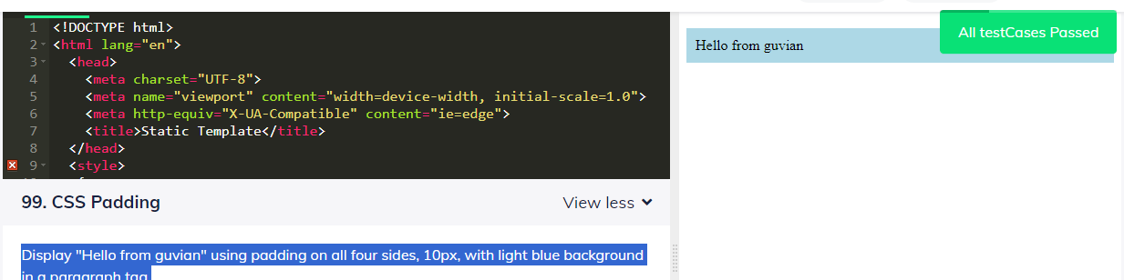

16. Display an statement "Hello From Guvian!" in a h1 tag and underline it using CSS

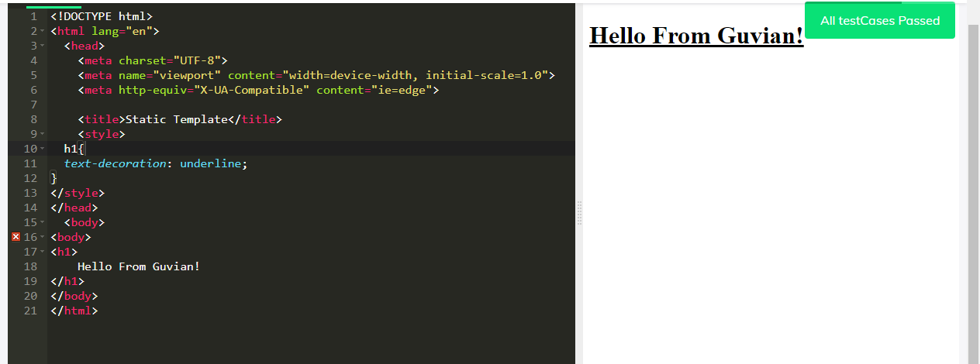

17. Display "Hello from Guvian" in a margin of 20px with pink background in a paragraph tag

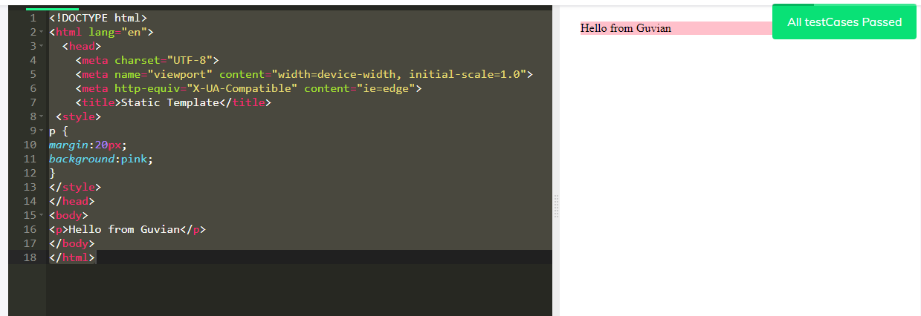

18. Display "Hello from Guvian" in red colour, aligned center using CSS selector in paragraph tag

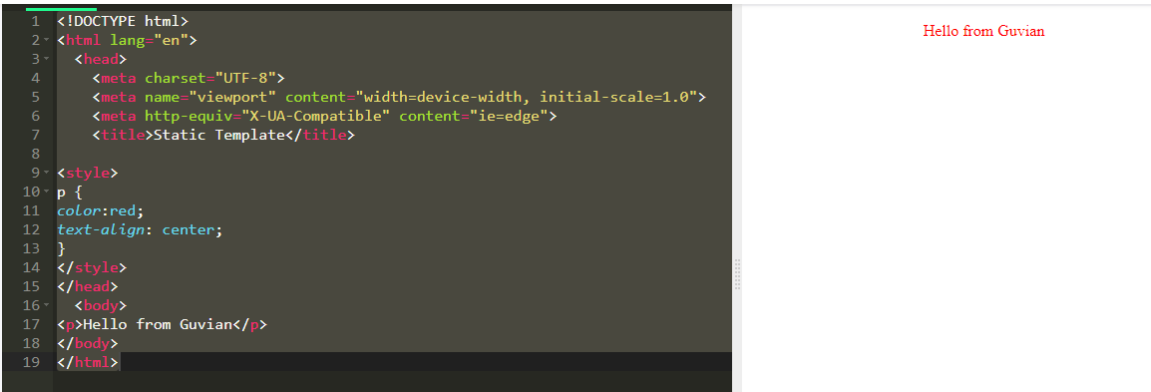19. Give a bottom-padding of 10px to the h2 heading using CSS

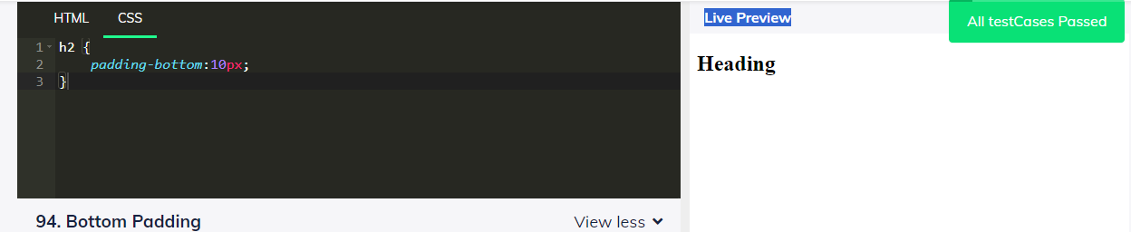

20. Give a top-padding of 10px to the h2 heading using CSS

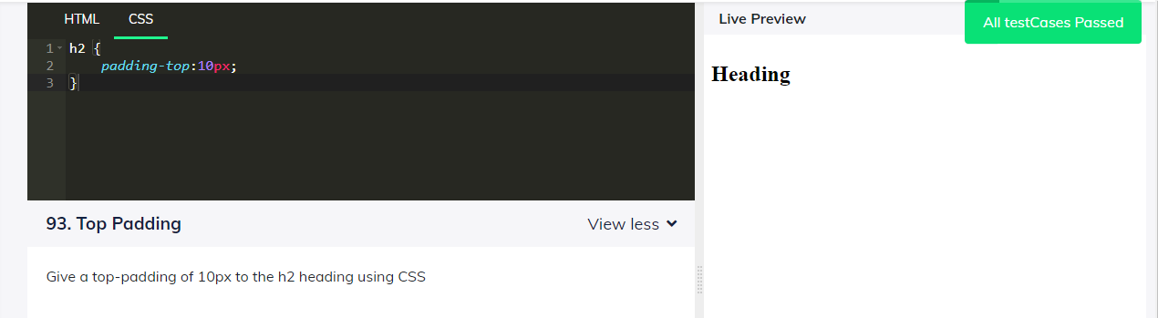

21. Give a left-padding of 10px to the h2 heading using CSS

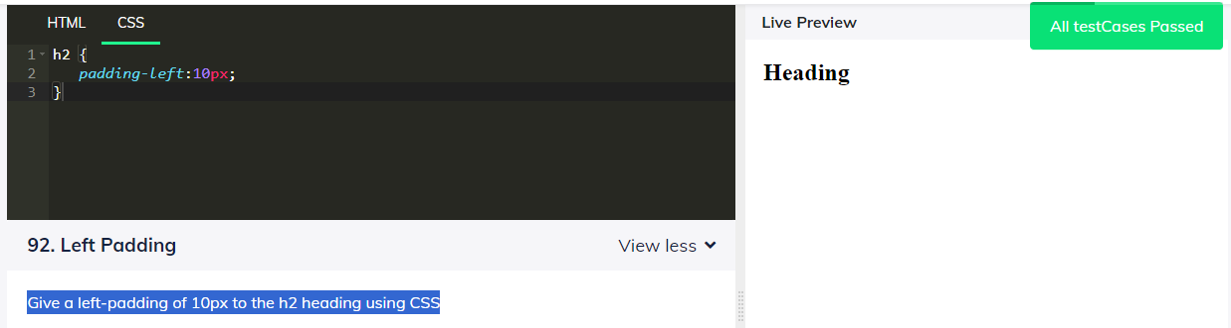

22. Give a padding of 10px to the h2 heading using CSS

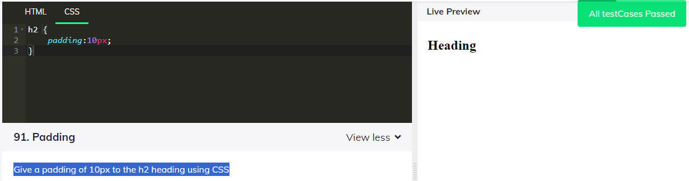

23. Make the edges of the given green square rounded with a border-radius of 10px using CSS

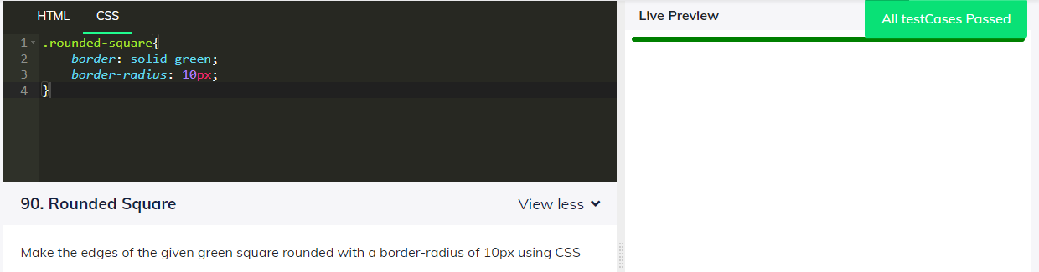

24. Display all the paragraph element in green color using CSS

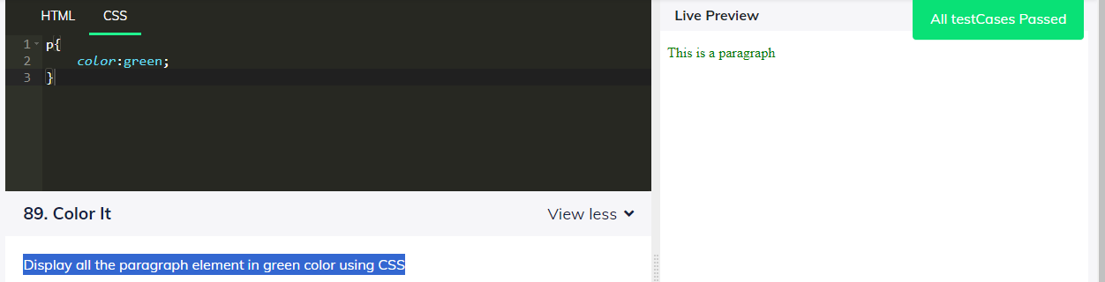

25. make direct children of the grid container automatically become grid items using display property (grid-container) css selector.

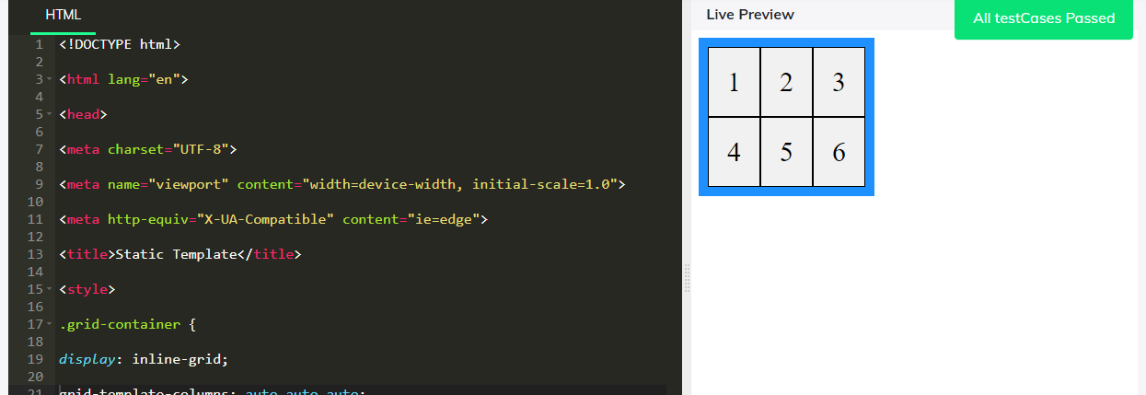

26. Set flex-items in the center using the justify-content property

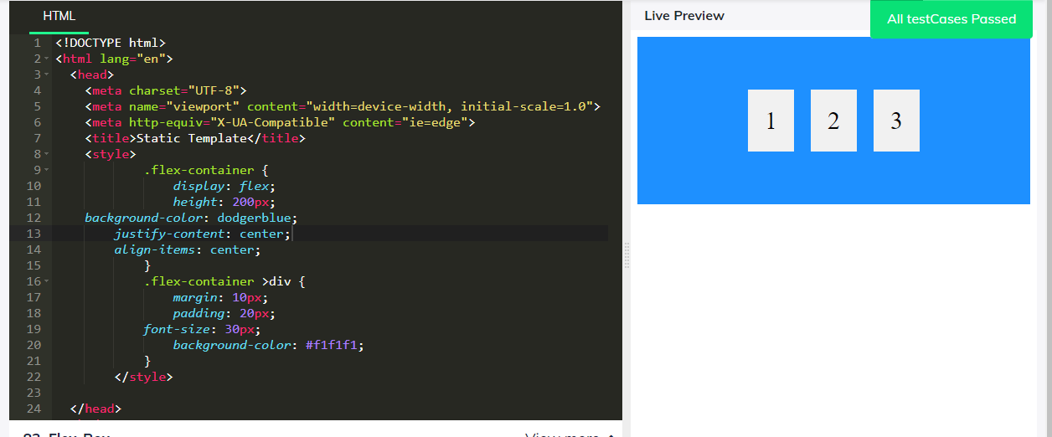

27. Change the direction of flex-items to row-reverse using the flex-container selector

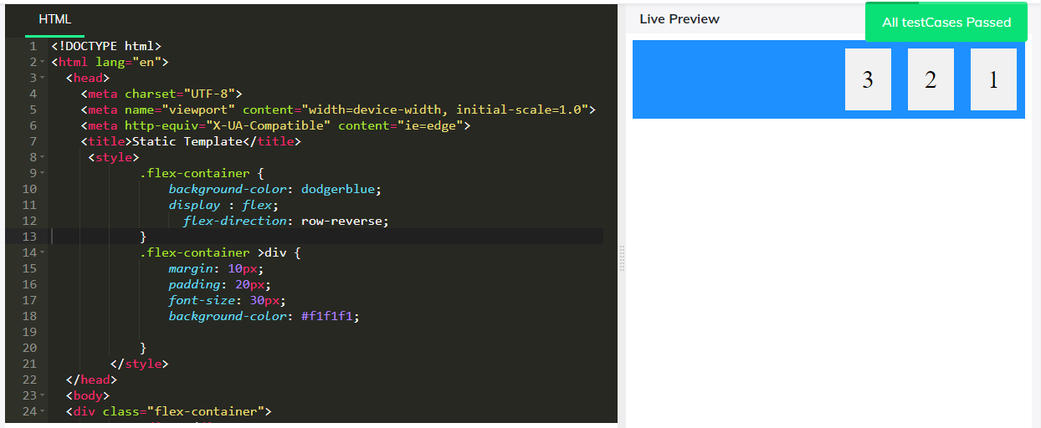

28. Set the width of the given button to 100% using CSS

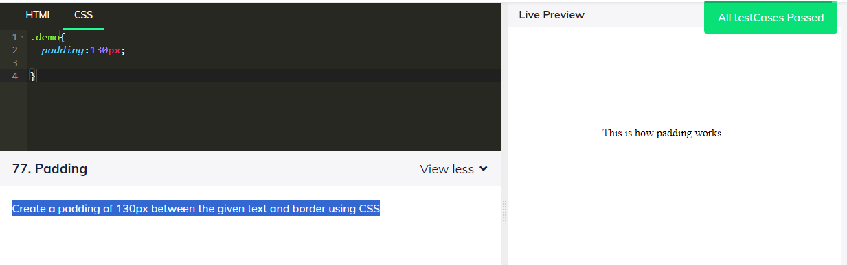

29. Set the width of the given button to 100% using CSS

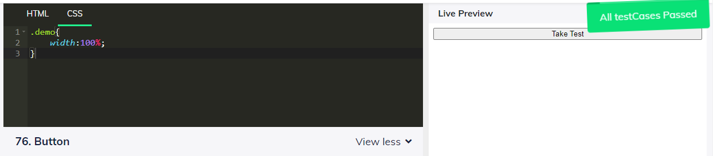

30. Add text shadow of 2px horizontal 2px vertical and 5px blur effect of color red to the given paragraph 'This is a technical issue'

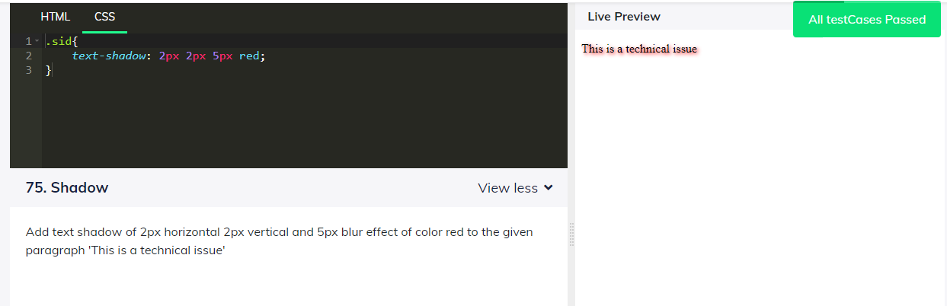

31. Separate the given words of a paragraph 'This is spacing' with a space of 20px using css

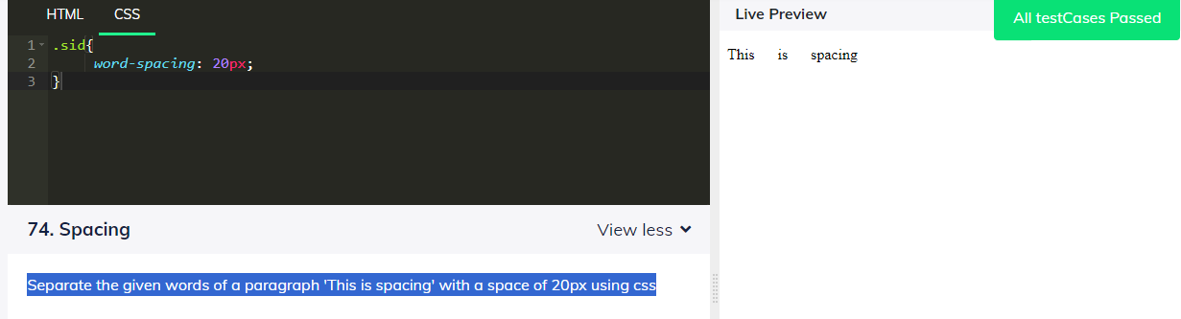

32. Change the entire text of the given paragraph 'This is some text' to lowercase

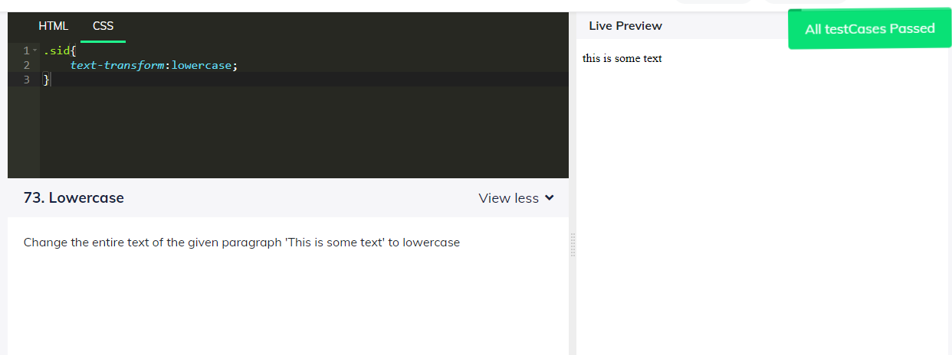

33. Capitalize the given paragraph 'This is some text' using css

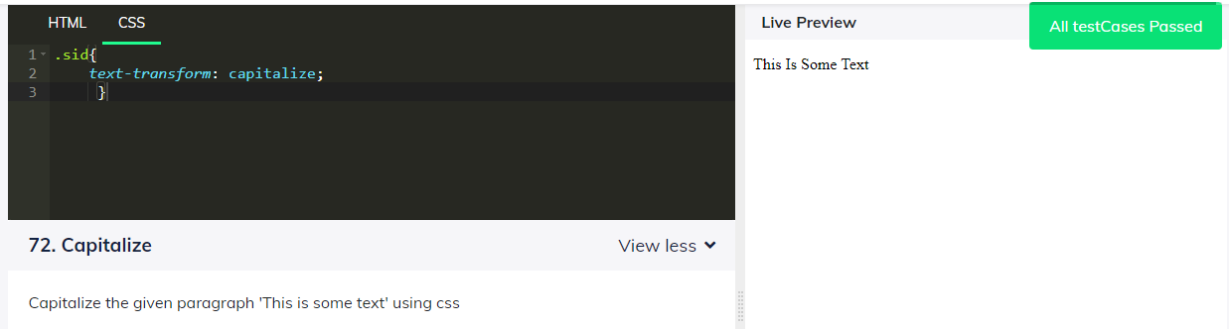

34. Place a solid border of width 10px around the given paragraph 'Pen is better than Sword'

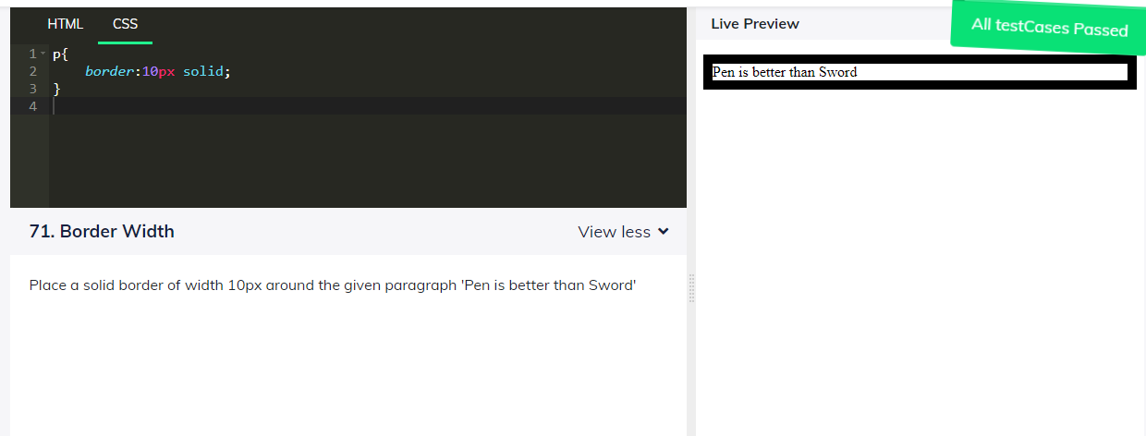

35. Place an dashed blue border around the given paragraph 'I have a blue border' of width 5px

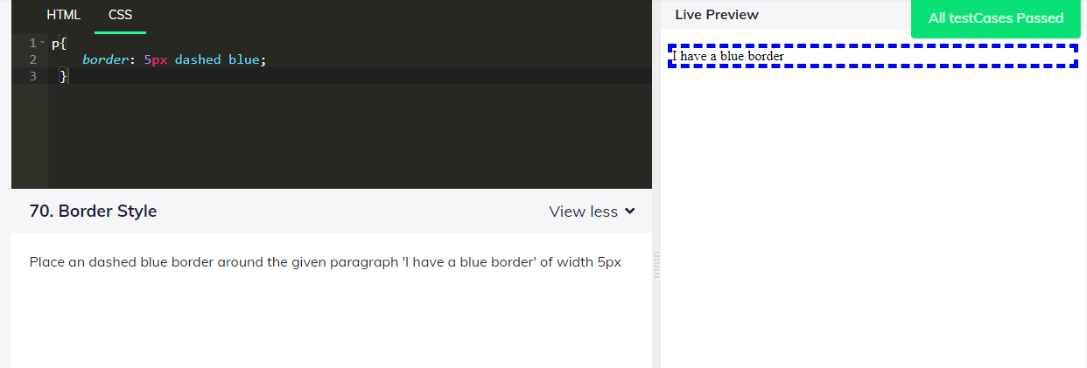

36. Add font-family 'courier' to the given paragraph text "This is a paragraph"

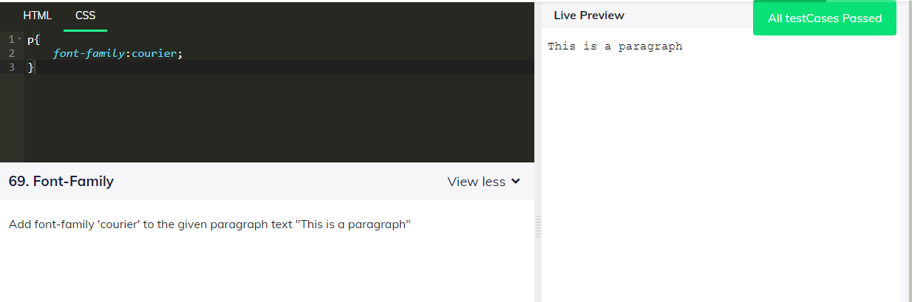

37. Change the opacity of the given text "Nice to meet you." to 0.5 and set background color as blue

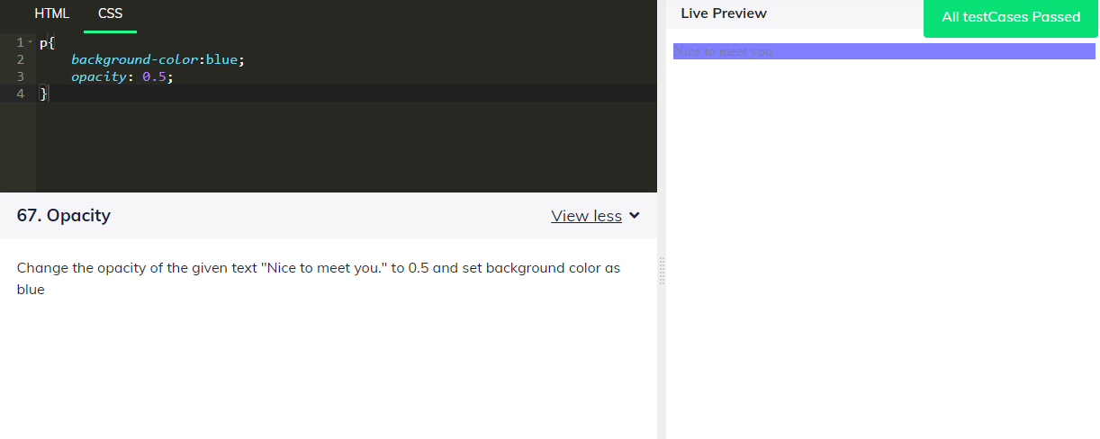

38. Change font size of all the elements with class name as 'size' to 60 px using css.

Display grid-items by using "justify-content : space-between", change row size value as 100px 80px

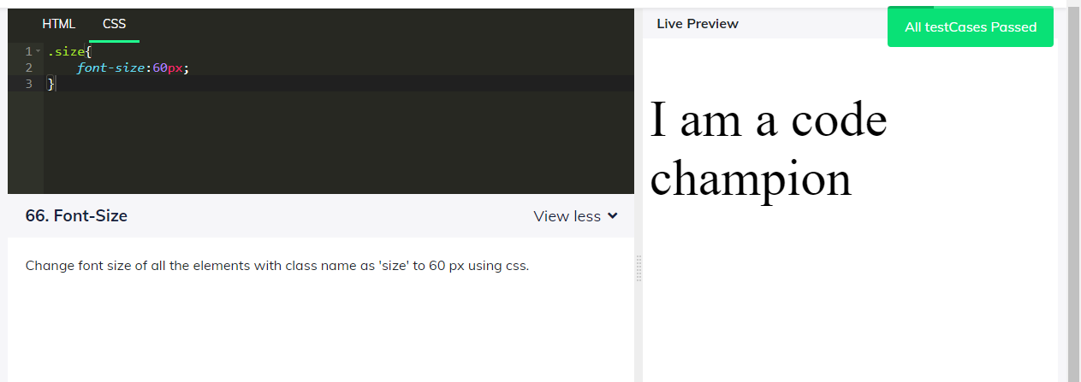

39. Display grid-container by changing column size to 100px 200px auto using the grid-template-columns property

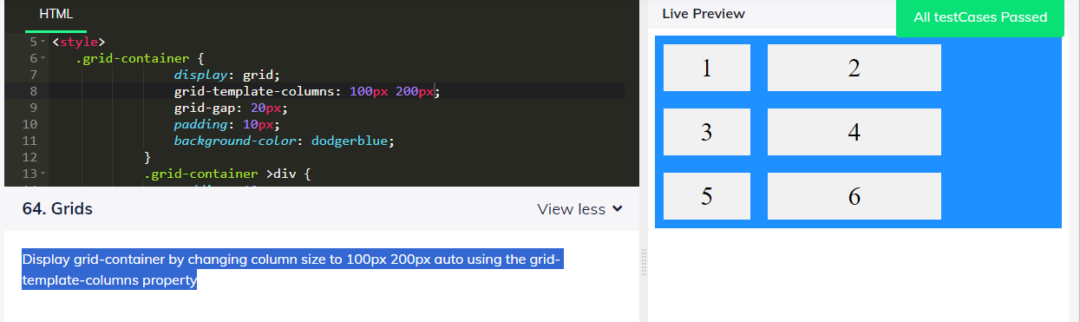

40. Display a container by changing row size to "200px 300px 500px " using the grid-template-rows property using the css selector (.grid-container)

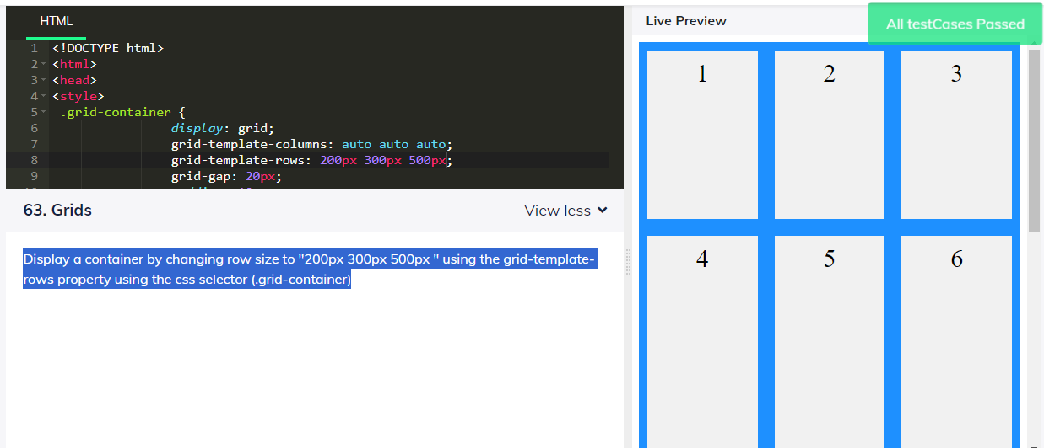

41. Display grid items with a height of 400px using the css selector(.grid-container)

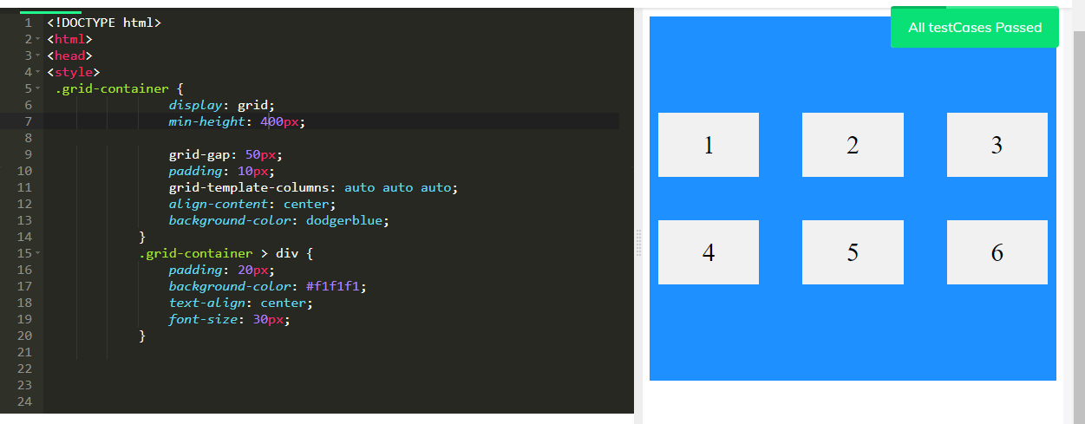

42. Display the grid items and change the grid-template-rows property to '150px 300px' using the css selector

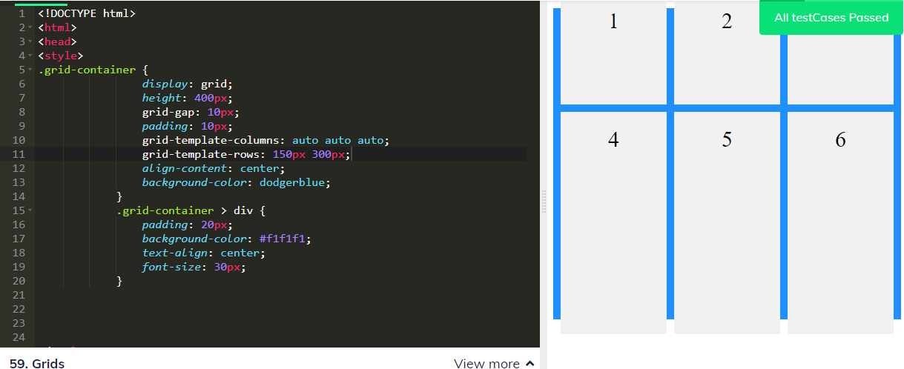

43. Display the grid items by using the property "justify-content : space-evenly

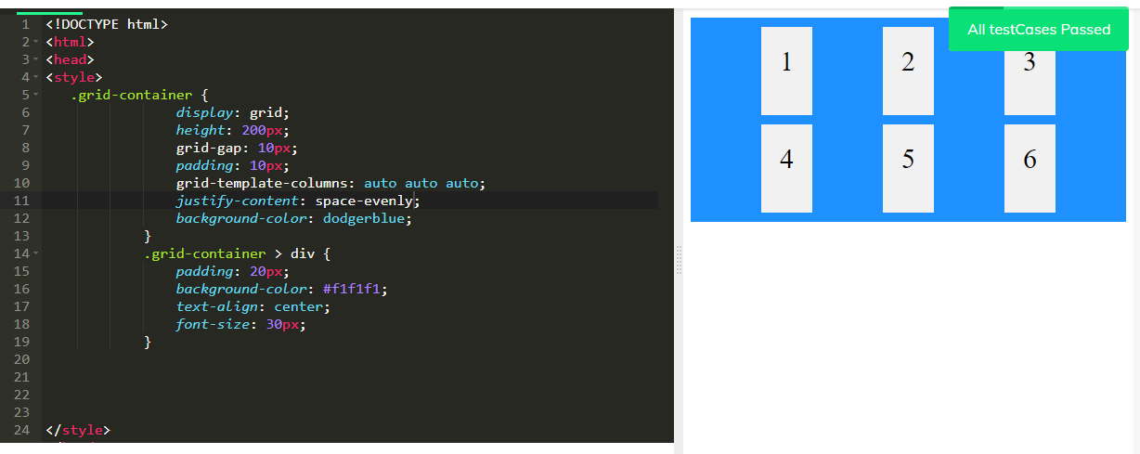

44. display the grid items with a grid row gap of50px using the css selectors(.grid-container)

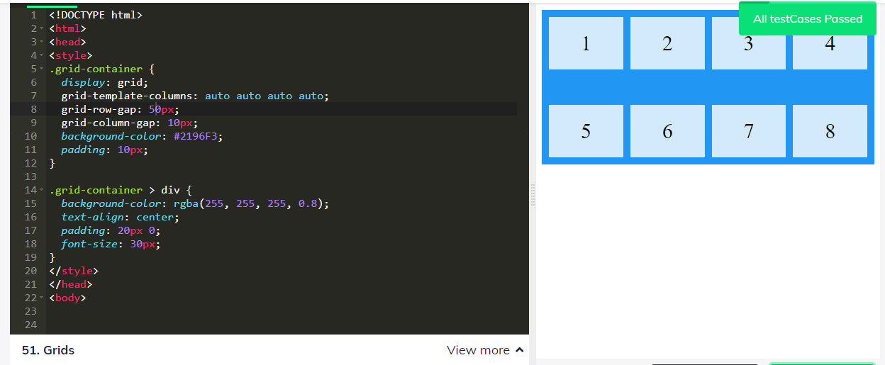

45. display the grid items with a value of 80px 80px using the grid template column property using the css selector(.grid-container)

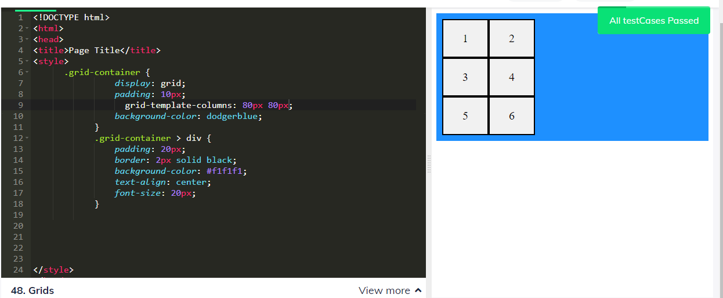

46. Display grid with 3 rows, change size of the row as 60px, 100px,using the grid-template-rows property

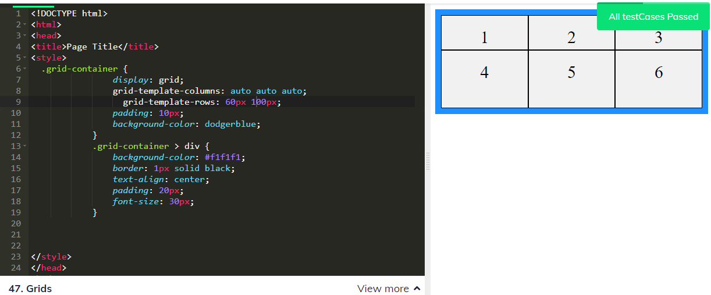

47. Display a grid-container with 3 rows and change the grid-template-rows to 80px, 50px and with a padding value of 10px using the css selector(.grid-container)

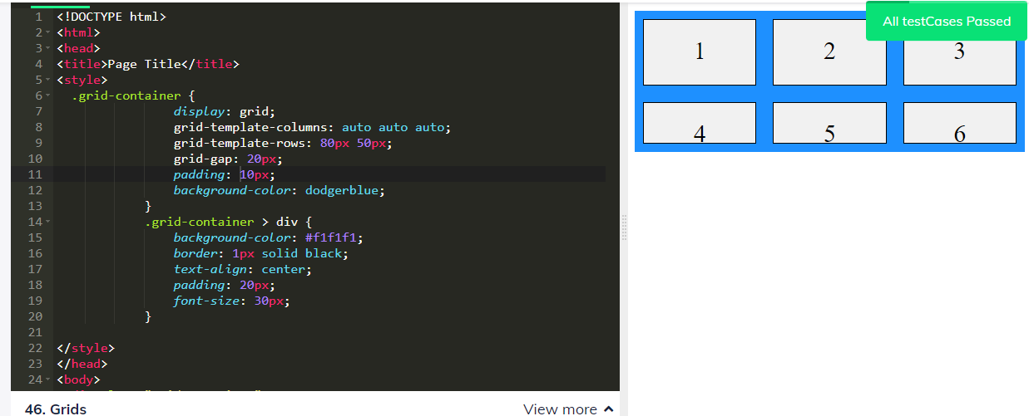

48. Display grid with 4 columns, change size of the column and give a gap of 20px using grid-gap property in the selector(.grid-container)

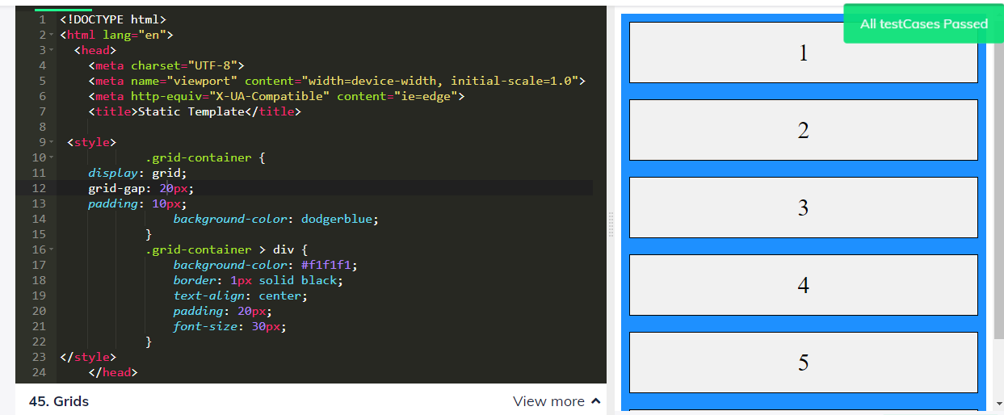

49. Display grid with 3 columns, change size of the column as 80px ,80px, 80px using the grid-template-column property.

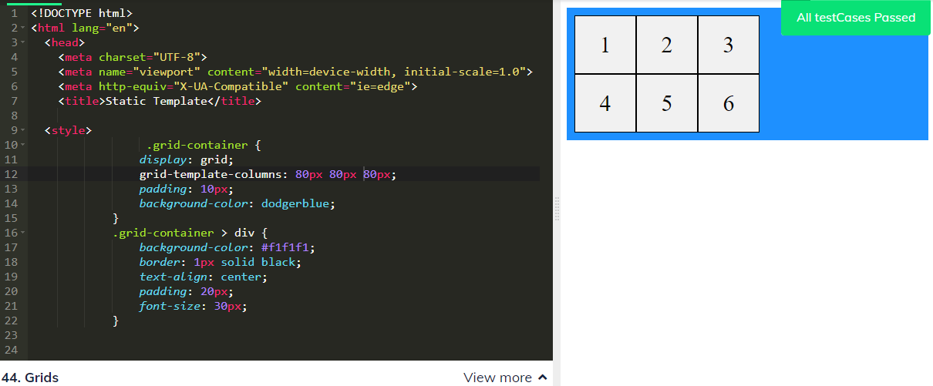

50. Display a grid-container with 3 rows and change the grid-template-rows property to 80px, 50px using the css selectors

